Quay Lane Surgery

Patient Information

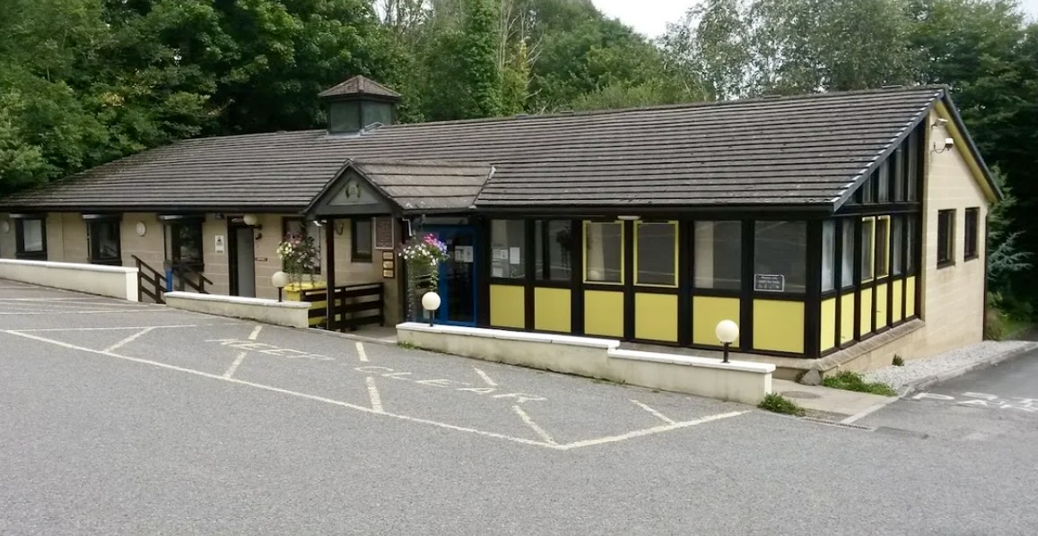
Old Quay Lane
St. Germans
Cornwall
PL12 5LH

Telephone: 01503 230088
E-Mail: quaylane.surgery@nhs.net
Website: www.quaylanesurgery.co.uk

You can also find us on Facebook

INDEX

Welcome ……………………………………………… Page 3

The Doctors ……………………………………………… Page 4

Practice Manager ……………………………………………… Page 5

Practice Team ……………………………………………… Page 5

Appointments and Access ……………………………………………… Page 7

Test Results ……………………………………………… Page 10

Prescriptions ……………………………………………… Page 10

Facilities and Services ……………………………………………… Page 12

Carer’s Register ……………………………………………… Page 14

Boundary Catchment Area ……………………………………………… Page 14

Compliments / Complaints ……………………………………………… Page 16

Interpreters ……………………………………………… Page 18

Mobile Phones ……………………………………………… Page 18

NHS 111 ……………………………………………… Page 18

Non NHS Services ……………………………………………… Page 19

Patient Participation Group ……………………………………………… Page 19

Zero Tolerance ……………………………………………… Page 19

Practice Privacy Notice ……………………………………………… Page 20

Summary Care Record ……………………………………………… Page 20

Data Protection ……………………………………………… Page 20

Social Services ……………………………………………… Page 20

Patients Rights /

Responsibilities /Your Rights ..……………………………………………. Page 21

Your Responsibilities ……………………………………………… Page 22

Useful Contacts ……………………………………………… Page 22

Welcome to Quay Lane Surgery

We wish to thank you for registering with our practice. The practice has been established in St. Germans for at least one hundred and fifty years and takes pride in offering a professional service to all our patients. Always people-centred, we endeavour to create a genuinely caring environment both for our patients and for our staff whilst also encouraging patients to take responsibility for their own health. We operate from a purpose-designed building completed in 1991. To accommodate our expanding needs we extended the surgery in 2006. Its design has been given to energy efficiency and conservation as well as functionality.

We also have a branch surgery in Downderry (at Broad's Yard, Downderry, Torpoint PL11 3LX). The Downderry surgery is open every weekday but closed on Tuesday and Friday afternoons.

This booklet contains information about the facilities and services at the practice and we hope you will find it useful and keep it handy for reference.

If you wish to register as a New Patient, please come to the reception desk to pick up the registration forms or download them from our practice website where you can also find updated information about the practice: www.quaylanesurgery.co.uk

Quay Lane Surgery Downderry Surgery
Opening Times: Opening Times:

Monday 8.30 - 1.00 / 2.00 - 6.00 Monday 9.00 -12.30 / 2.00 – 6.00
Tuesday 8.30 - 1.00 / 2.00 - 6.00 Tuesday 9.00 -12.30 / Closed
Wednesday 8.30 - 1.00 / 2.00 - 6.00 Wednesday 9.00 -12.30 / 2.00 – 6.00
Thursday 8.30 - 1.00 / 2.00 - 6.00 Thursday 9.00 -12.30 / 2.00 – 6.00
Friday 8.30 - 1.00 / 2.00 - 6.00 Friday 8.30 -12.30 / Closed

Emergencies:
For life threatening emergencies such as:
- Severe bleeding
- Collapse or unconsciousness
- Severe chest pains
- Stroke
Telephone 999 for an ambulance IMMEDIATELY, then inform your Doctor.

When the Surgery is closed
We close between 1.00pm and 2.00pm each day.
When the practice is closed, please telephone the surgery on 01503 230088 and you will be transferred directly to NHS 111
If you are unable to contact the Doctor and the emergency persists, ring 999 without delay.

THE DOCTORS:

Patients are free to consult whichever Doctor they choose, irrespective of the Doctor with whom they are registered. All our GPs are registered with the General Medical Council.

The Partners

Dr Simon Fullalove MRCP, MRCGP, DRCOG
Trained at Manchester University and qualified in 1987. He worked extensively in a variety of hospital medicine departments in Manchester and Liverpool and achieved Membership of the Royal College of Physicians in 1991. He subsequently completed further vocational training in Accident & Emergency Medicine, Paediatrics, and Obstetrics & Gynaecology. He became a partner in the practice at St Germans in 1995. He is a Member of the Royal College of General Practitioners and holds the Diploma of the Royal College of Obstetrics & Gynaecology and the Diploma of the Faculty of Family Planning.

Dr Jonathan Carty MB ChB, DRCOG, MRCGP
Dr Carty qualified from the University of Aberdeen in 1997 and served in the Royal Navy until 2004. During this time he saw active service around the world including East Timor and Sierra Leone. He was awarded QCVS in the Queen’s Operation Honours List in 2001 for his role in Operation Barras in 2000. He also served at RNAS Culdrose providing medical support to 771 Naval Air Squadron, regularly flying on Search and Rescue Missions. His GP training in Derriford Hospital included working in A&E, ENT, Ophthalmology, Obstetrics and Gynaecology and General Medicine. For 10 years prior to joining Quay Lane Surgery he worked as a full time GP Partner at Lifton Surgery in West Devon. He is interested in all areas of medicine, particularly ophthalmology, ENT disorders, family medicine and palliative care.

Salaried GPs

Dr Emma Knight MB ChB, MRCGP, DRCOG
Dr Knight qualified from Aberdeen University, doing an elective with an ER and Air ambulance in Florida, followed by a rotation with cardiothoracic surgery, orthopaedics and trauma. She was sponsored by the Royal Navy in medical school, then served as a Doctor with Search and Rescue in Cornwall and at HMS Raleigh with the new recruits. She was also the Doctor for two 7-month deployments, one which circumnavigated the globe and one which included time in Sierra Leone. Dr Knight has worked in A&E, Obstetrics and Gynaecology, ENT, Opthalmology and General Medicine in Derriford during General Practice training and loves all aspects of helping patients. She has 4 school age children and loves running, cycling, stand up paddle boarding, travelling and generally being busy!

Dr Ayla McCamphill-Rose BSc, MBBCh, MRCGP, DipSEM
Originally from the Midlands, Ayla McCamphill-Rose qualified from the University of Wales, College of Medicine, in 2003 after playing as much rugby as she could. She then remained in the South Wales Valleys for further medical and GP vocational training before following her partners’ career to Wiltshire, London, Bristol, Portsmouth, Italy and Devon. She has worked as a locum, salaried GP and partner in various NHS settings across the South of England and London. Completing a Post Graduate Diploma in Sports & Exercise Medicine at Bath University has afforded her posts in international rugby, premiership football, London 2012 Olympics and military medicine at the Institute of Naval Medicine, NATO Naples and BRNC Dartmouth. She has recently become a civilian GP for Plymouth based Commando units as well as joining Quay Lane Surgery where she hopes to help patients keep doing the things they love - healthy and happy. She enjoys all things musical, aquatic, equestrian and alpine and with her record-breaking disco dancing family Ayla is looking forward to enjoying everything Cornwall has to offer and never moving house again.

Dr Jack Pothecary MBChB MRCGP PGCert
Dr Pothecary qualified from the University of Liverpool in 2018. He initially worked in Blackpool Victoria Hospital, spending time in both medical and surgical departments – this included working in Obstetrics and Gynaecology, Diabetes and Endocrinology as well as Paediatrics. During this time, he also completed a Postgraduate Certificate in Medical Leadership with Distinction. His GP training was undertaken Devon, mainly based at Derriford Hospital including time within ENT, Palliative Care and Cardiology. During this period of training, he also had exposure to multiple community-based clinics including Dermatology, Sexual Health, Mental Health and Addiction Services. After qualifying as a GP he joined Quay Lane Surgery and works part time with the Acute GP Service at Derriford Hospital. He fills his free time with water sports, trekking and DIY!

PRACTICE MANAGER – Mrs Debbie Todd
Debbie is responsible for the overall management and smooth running of the practice and is trained in Primary Care and Health Management (DipPCHM). She will be pleased to discuss any non-medical problems with you and welcomes any suggestions you may have for improving the service provided. She is responsible for the practice complaints procedure.

East Cornwall Primary Care Network
Quay Lane Surgery is part of the East Cornwall Primary Care Network which covers the Rame Peninsula, Looe, Liskeard and Saltash. The practices that make up our PCN are: Quay Lane Surgery, Port View Surgery, Saltash Health Centre, Old Bridge Surgery, The Rame Group, Oak Tree Surgery and Rosedean Surgery.

PRACTICE TEAM:

Reception Staff and Administration Staff
Our reception staff are here to help you. When telephoning for medical attention our reception staff may ask for a few details. The Doctors have asked them to make these enquiries so that they can help you in the most appropriate way. Our reception staff have undertaken special training and always respect patient confidentiality.

Practice Nurse
Our Practice Nurses are available by appointment for various treatments, chronic disease, health promotion advice and screening, including smears, immunisations and vaccinations. When booking an appointment with a Practice Nurse, our reception staff will need to ask you the reason for an appointment to determine how much time to allocate.

Healthcare Assistants
Healthcare Assistants are not qualified as nurses but have undergone training to enable them to: take blood (phlebotomy), do blood pressure checks, ECG’s, give weight management advice, give smoking cessation advice and to perform well person checks and hearing tests when requested by a GP. They can assist in the family planning clinics, minor surgery clinics, chronic disease and immunisation clinics. They are also able to administer flu, pneumonia and B12 injections and remove sutures.
First Contact Physiotherapist – Paul Sumner
We offer First Contact Physio appointments on a Tuesday with Paul. He is an Orthopedic Extended Scope Practitioner and will deal with patients aged 18 and over presenting with musculoskeletal problems.

Clinical Pharmacists – Nicola Stephens & Tina Mistry
Nicola and Tina offer appointments for medication reviews and will happily discuss any medication concerns that you may have.

Social Prescriber – Lisa May
Our Social Prescriber is able to deal with a variety of social issues including:

- Social isolation or getting out and about
- Befriending services
- Bereavement
- Accessing legal advice
- Emotional wellbeing & mental health support
- Being a carer
- Respite services and Cancer Care Services
- Long term health support
- Accessing the workplace
- Volunteering or joining groups
- Debt management
- Healthy lifestyle & weight management
- Digital access to services

District Nurses
District nurses assess, plan and manage the care of sick and disabled patients of all ages in the patient's own home and residential nursing homes and provide support for their carers. Individual care is planned, and advice on further help or services is given including health education. They have a close liaison with the Hospital, GPs, the local hospice, and other specialised services. They administer drugs, give injections, dress wounds, take blood samples and give personal care. The District Nurses are in regular contact with the practice. This service is only available for housebound patients.

Community Matron – Sara Williamson

Health Visitors
Health visitors can provide you with help and information regarding such issues as emotional problems, relationship difficulties, family planning and health problems and advise on healthy eating.

APPOINTMENTS & ACCESS TO THE SURGERY:

All our regular weekday surgeries are by appointment only. Please see our reception staff or telephone the practice during Opening Times on 01503 230088 to arrange an appointment to see one of our Health Care Professionals. Please ask the receptionist for more details.

The Doctor will try their best to give enough time to each patient but if, for example, two members of one family try to be seen in a single appointment, other patients will be kept waiting. So please make an appointment for each person wishing to be seen.

If you think that your problem may take an unusually long time, please inform our reception staff so that allowances can be made for this.

Patients are automatically allocated to a GP when registering at the surgery, however patients can have appointments with any GP of their choice when available. The surgery urges patients to help us keep continuity of care by seeing the same GP about ongoing problems and conditions when possible.

Urgent Appointments

If you have an urgent medical problem that you feel needs attention on the same day, please explain this to our reception staff who will book you an appointment with the most appropriate clinician or member of our health professional team. They may also offer you a video consultation with a LIVI GP.

If the Doctor thinks you need to be seen, you will usually be offered an appointment that day.

Cancelling Appointments

If you are unable to keep your appointment, please let us know either by telephone, online or in person, as soon as possible so that we can allocate it to someone else,

Patient Triage

This service gives patients the opportunity to consult with one of the practice GPs on-line. You will be asked a series of questions about your condition. Patients can expect to receive communication from the surgery with advice, a prescription, an appointment or a phone consultation with a GP by the end of the next working day. It is NOT to be used for urgent advice. There is also an option to request admin advice i.e.. request sick notes, chase up results or reports, general enquiries.

LIVI – Video Consultations

You are now able to access a GP by video consultation during the evening and weekends (you must have a smart phone to access this service). You can book an appointment via the receptionist. See website or ask at reception for details of this service.

Access to Services by people with Disabilities

The practice in St. Germans has done its utmost to be easily accessible and user-friendly for our disabled and wheelchair-bound patients. A wheelchair is available for those with difficulty in walking - this can be available on request at the practice.

- There are designated parking spaces in the car park.

- An induction loop is available to help the hard of hearing have clearer conversations. This can also be provided for individual consulting rooms when necessary.

- Surgery rooms are all located on the ground floor.

- There are also toilet facilities for the disabled in the surgery.

If you experience any problems, please speak to our reception staff, who will do their utmost to assist you. The Downderry Surgery has no disabled facilities.

Other Access Issues:

Prams
Prams can be brought into the surgery or may be left in the outer foyer of the main entrance to the practice at your own risk.

Dogs
All dogs, with the exception of assistance dogs, should be left outside the building. There are hooks for this purpose to tie them on their leads around the side of the building. We kindly ask that you do not walk your dogs on the grassed area behind the surgery.

Self-Check-in
The main surgery has an automated self-check-in touch screen in the waiting room. This is a simple-to-use system that enables the patient to check themselves into our appointments system.

Should you feel uncomfortable about using such a system, you can obtain help, or book in with our reception staff in the traditional manner.

Home Visits
As home visits are for those patients too ill to attend surgery, please only request a home visit if you (or the person you are calling on behalf of) is too ill or frail to attend the practice. Please remember the Doctor can see four patients in the time it takes to make one house call. We ask that you ring the surgery before 10am. The Doctor may arrange for the patient to be brought to the surgery so that its full facilities are available for tests and treatment.

It is not possible to request a specific Doctor for a home visit although we can note your request.

Please give clear directions so the Doctor can locate your house. If you have an outside light, please ensure that it is switched on during the hours of darkness. If you have a dog that is not familiar with visitors, please ensure that it is securely locked away.

Hospital Referrals
Wherever possible, routine hospital referral letters will be done within 3 days, or on the same day, if very urgent. Decisions regarding your treatment, including the options open to you, will be explained and discussed with you before any referral is made.

Out-of-Hours Appointments:

Practice patients who have urgent medical problems that will not wait until normal working hours may ring the out-of-hours service. This service is available by contacting NHS 111.

The out-of-hours service will contact the most appropriate healthcare professional (GP or Nurse) who will call you back to discuss your problem and, after taking a full history, will either:

- Give advice over the phone
- Ask to assess the patient at the GP base
- Visit the patient at home
- Admit the patient directly to hospital via 999 ambulance
The Out-of-Hours service is provided by NHS Kernow and any queries, comments or complaints should be directed to them via email: england.contactus@nhs.net

Help and advice is also available 24 hours a day, seven days a week from NHS 111 who can be contacted by telephone on 111. If you have difficulties communicating or hearing, you can call 18001 111 on a text phone.

Online services:

Patient Access
To register with our on-line service Patient Access you will need to be 16 years of age or older. Patient access links you directly with the practice IT system and your medical record. Registering with Patient Access is easy – all you need is a unique e-mail address. Pick up a consent form from reception or download from our practice website. You will need to provide ID to register for this service. Once registered you will have access to some areas of your medical records, be able to order medication and book appointments.

NHS App
The NHS App is a simple and secure way to access a range of NHS services on your smartphone or tablet. The NHS App is available now on iOS and Android. To use it you must be aged 13 and over and registered with a GP surgery in England. You can use the NHS App to:

- share your COVID-19 vaccination status
- order repeat prescriptions
- get health advice
- view your medical record (if you are registered for Patient Access at your surgery)
You do not need to be registered for online access at your surgery to order medication or view your COVID-19 vaccination status.

TEST RESULTS

Please allow 5 working days for test results to come back (Smear tests usually take about 6 weeks).

Please telephone 01503 230088 after 10am to obtain details of your test results (e.g., blood, urine, x-ray), or visit the practice.

To ensure confidentiality and security, test results will only be given to the patient direct and not to relatives or friends, unless alternative arrangements have been agreed in writing.

We will, of course, make every effort to contact you should your returned result need urgent action. However, it is your responsibility in all cases to find out the result of your test.

The Doctors check the results before our reception staff are able to give any information to you. Our reception staff will only be able to state that the result is normal or that you will have to see the Doctor.

Please do not expect our reception staff to relay any other information regarding the test results.
If the Doctor needs to speak to your personally, our reception staff will suggest the best possible time to ring, to avoid interruptions during the surgeries, which is upsetting for both the Doctors and our patients.

SICKNESS CERTIFICATES

Under current legislation a patient can “self-certificate” for the first 7 working days of any illness. The self-certificate (Form SC2) is available from the DSS office or your employer. We do not normally issue Doctors certificates for the first week.
After the first week, if you require a free Statement of Fitness for Work (Fit Note) please contact the surgery and speak to a receptionist or request a certificate via e-consult on the practice website.

PRESCRIPTIONS

We have an in-house dispensary at the main surgery in St. Germans. We can normally dispense for all our patients if they do not live within 1 mile (1.6km) of a chemist.

We keep a comprehensive stock of medicines at St Germans and a more limited one at Downderry. From time to time, we may have to order some medicines – we can usually obtain these within 24 hours. In order to reduce our prescribing costs, we may dispense the generic equivalent of some of the medicines you are used to. They will basically be the same drug but may be made by a different manufacturer.

Repeat Prescriptions

If you have repeat medication, we will keep a record on the computer. You will be asked to attend for review from time to time to make sure that the medication is still appropriate or if a change is needed.

To order your repeat prescriptions please return the prescription counterfoil marked with the medication you require to the main surgery or branch surgery. Alternatively, you can order using our website: www.quaylanesurgery.co.uk by registering with ‘Patient Access’, NHS App or by post. We are sorry that we cannot accept orders for repeat prescriptions over the phone as this can very easily lead to mistakes.

Please give us at least 5 working days’ notice to prepare your order to collect from St. Germans or 6 working days from Downderry.

Medication can be collected at St. Germans or Downderry surgeries so please specify when you make your request where you wish to collect them. When you collect your prescription, please check that it is correct before you leave the surgery.

The dispensary is open:

Monday 8.30 – 1.00 / 3.00 – 6.00
Tuesday 8.30 – 1.00 / 3.00 – 6.00
Wednesday 8.30 – 1.00 / 3.00 – 6.00
Thursday 8.30 – 1.00 / 3.00 – 6.00
Friday 8.30 – 1.00 / 3.00 – 6.00

If you require urgent medication when the dispensary is closed, you should contact NHS 111.

It is likely you will be asked to see a Doctor every few months so your condition can be reviewed. You will also be given a computer list of your medication to make re-ordering easier. You will be issued with a computer-printed prescription.

- Please let us have this slip at least 5 working days before you require the prescription
- We do not accept prescription requests over the phone
- If you would like a prescription posted to you, please enclose a stamped, addressed envelope.
- Order early to allow for postal delays, especially on Public or Bank Holidays.

FACILITIES & SERVICES AVAILABLE AT THE PRACTICE

We have:
- Rooms available for access by disabled people
- Nappy changing facilities
- Quiet areas to discuss private matters
- A comfortable waiting area (our practice is cleaned and checked every day)

We will keep you informed through:
- Notice boards and a television screen in the waiting room
- Our website and other social media – Facebook, email and texts
- The local Nut Tree magazine

Coils & Contraceptive Implants
Our nursing sister can check and remove IUCDs at the practice. We can refer you to a local clinic for insertions for coils and implants. Ask your reception team, nurse or GP for information.

Long Term Conditions
If you suffer from a long-term condition then our Practice Nurse will review your care annually. You are able to book an appointment to discuss any issues ahead of your annual review.

Family Planning & Sexual Health
The practice offers a full range of contraceptive services. Please ask our reception staff for details. If you have any concerns about sexual health, contraception or related matters please ask for an appointment with the Practice Nurse. This will be treated in strictest confidence.
Flu Vaccinations
An influenza vaccination is particularly recommended for patients over the age of 65 or in ‘at risk’ category. Please contact our reception staff in early October for details of the vaccination dates. If you are housebound, a home visit by a community nurse or GP will be arranged to administer this vaccination.

Pneumonia Vaccinations
If you are aged 65 or over, you are strongly advised to have a pneumonia vaccination. Appointments with the nurse can be booked with our reception staff.

Travel Advice
We are available to help you with all your travel health enquires and necessary immunisations. Information on travel can be found by following the links on our practice website or by visiting www.fitfortravel.scot.nhs.uk

Minor Surgery and Cryotherapy
Sessions are held at regular intervals with a GP for the removal of skin lesions, moles, warts, verrucae, etc. This is usually undertaken by the application of liquid nitrogen (Cryotherapy) or occasionally with minor surgery. It is essential that patients have an appointment with the GP first so that the lesion can be properly assessed. If we are able to remove it at the surgery, we will arrange for patients to have an appointment at the minor surgery clinic.

Minor Injuries
The practice provides a Minor Injury Service which is run during practice opening times 8.30am – 1pm & 2pm – 6pm (Monday-Friday). No appointment necessary.

Adult Health Checks
If you are Over 75 Years Old and have not seen us within the twelve months you can request a consultation for a check on your health. If you are aged 16-75 Years Old and have not been seen by the practice for three years you can request a consultation for a health check.

NHS Health Checks
This is offered to patients aged 40 to 74 with no pre-existing conditions and is designed to spot early signs of stroke, kidney disease, heart disease, type 2 diabetes or dementia. Ask at reception for details if you would like a check.

Cervical Smears
All women between the ages of 24½ and 65 years old will be offered cervical smears on a regular basis. If you would like to discuss any issues, fears or concerns you have about having a smear please ask to speak to Sister Claire May and she will be more than happy to reassure you.

Ante-Natal
These appointments are managed by the Community Midwife at the Torpoint Clinic.

Healthy Cornwall
Healthy Cornwall provides programmes for healthy weight, healthy pregnancy and to stop smoking www.healthycornwall.org.uk

They can be contacted by ringing 01209 615600 or by completing an enquiry form online.
Additional Information
The practice is committed to provide relevant information to people who use its services and the following methods will be used to provide this information:

- During their consultation
- Information Leaflets
- Practice booklet / leaflet
- Patient waiting areas television / Health Promotion TV Screens
- Practice website
- Regular newsletters and emails

If you require information on a specific topic and are unable to find it, please ask our reception staff, who will do their utmost to help you.

CARER’S REGISTER

The practice has a Carer’s Register for patients that are registered and who care for a relative/friend.
CHAPERONES

Our practice is committed to providing a safe, comfortable environment where patients and staff can be confident that best practice is being followed at all times and the safety of everyone is of paramount importance. All patients are entitled to have a chaperone present for any consultation, examination or procedure where they feel one is required. This chaperone may be a family member or friend.
On occasions you may prefer a formal chaperone to be present.
Your healthcare professional may also require a chaperone to be present for certain consultations in accordance with our chaperone policy. If you wish to have a member of the practice staff present during your consultation, please mention this to our reception staff when booking your appointment, or to the Doctor at your consultation, and it will be arranged.

BOUNDARY / CATCHMENT AREA / LOCATION OF THE PRACTICE
accept patients from the approximate area shown on the map below.
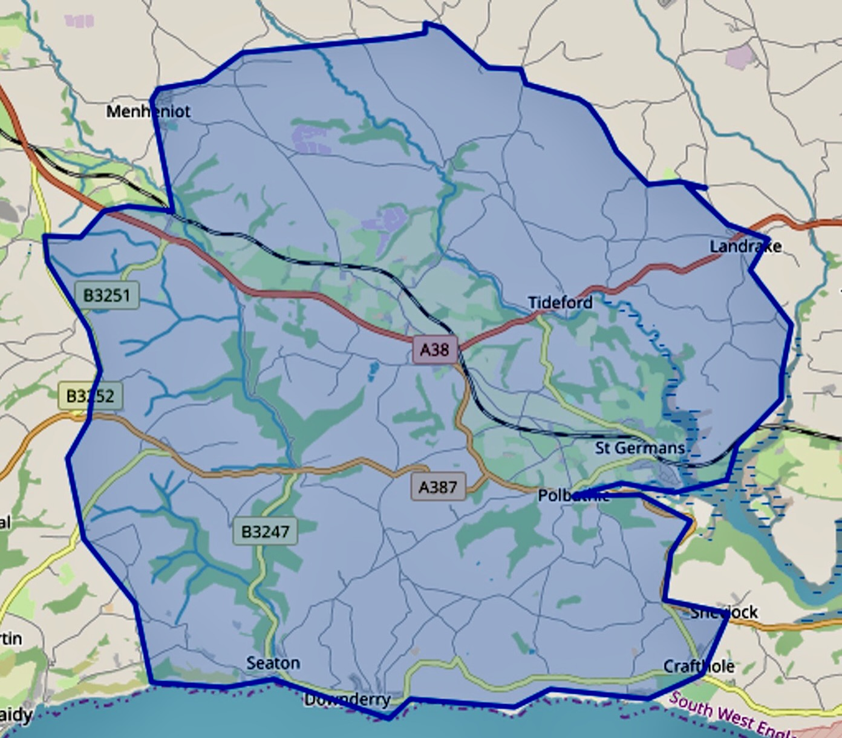

QUAY LANE SURGERY

St Germans PL12 5LH

DOWNDERRY SURGERY

Downderry PL11 3LX

We welcome new patients who are resident within our practice area. When you come to register you will be given a form to sign and will be allocated with a GP. You will receive an information pack with a short health questionnaire and an invitation to come for a consultation within 6 months to meet us so that we can put a 'face to the name' and at the same time carry out a short medical check-up.
We are unable to accept your registration if you live or move outside of the practice boundary. If you’re unsure then please check with our reception team. Alternatively, you can enter your postcode into our link on the registration section for new patients on the practice website to check if you are located in our area.

New Patients
The practice is able to take new patients providing they live within the practice area.
To register, complete a registration form obtained from our reception staff or download one from the practice website. In the case of a new baby, bring their NHS Number (obtainable from Child Health or the Maternity Ward) or the child’s red book. Please fill in our New Patient Health Questionnaire (downloadable from our website or available from our reception staff).

Your medical record may arrive electronically but sometimes we have to wait for it to arrive from your previous Doctor and this gives us the opportunity of recording some basic information about you and offering you any immediate care you may need.
We do not exclude patients from the practice on grounds of age, sex, colour, race, nationality, ethnic or national origin or disability, sexual orientation, religion or religious or philosophical belief or medical condition.

Car Parking
A car park is provided for patients who are visiting the main surgery, with designated parking spaces for the use of disabled patients. Please park only in the spaces provided and ensure you are not blocking the exit of a who may be called out on an emergency.
Please note that no responsibility can be accepted by the practice for damage caused to any vehicle using the car park.
There is no designated parking at the branch surgery in Downderry but there is a public car-park available close by.
Change in Personal Details
Please inform our reception staff if you change your name, address, marital status or telephone number, so we can keep our records accurate.
If you move out of the practice area it will be necessary for you to register with a Doctor at another practice which covers that area.
Our reception staff will help you with queries about practice boundaries.
Temporary/Short Term Residents
If you are visiting Cornwall and you or a family member need advice from a Doctor, contact your own GP practice by phone or via their website in the first instance.
If you need urgent advice out of hours, please contact NHS 111. Visit 111.nhs.uk or call 111.
We do provide a Temporary Patient Service for anyone staying within our practice area that needs to be seen (e.g., whilst on holiday, staying with relatives etc.); please contact the surgery.

COMPLIMENTS, COMMENTS AND COMPLAINTS
Compliments
We welcome compliments about our service so that we know what we are doing right and these are also shared with the practice team, which gives them a real lift. There is a suggestion / comments box located opposite the reception desk for this purpose or you can feed back via our website or email us directly.
Comments/Feedback
We welcome your views and constructive suggestions which will help us improve our service to you. There is a suggestion / comments box located opposite the reception desk for this purpose.
Practice Complaints Procedure
How to Complain
We hope that most problems can be sorted out easily and quickly, often at the time they arise and with the person concerned. If this is not possible and you wish to make a complaint, please inform us as soon as possible – ideally, within a matter of days or at most a few weeks. This will enable us to establish what happened more easily. If this is not possible please let us have details of your complaint within 12 months of the incident that caused the problem or within 12 months of discovering that you have a problem.
Complaints can be made verbally, in writing or electronically and addressed to the Practice Manager. Alternatively, you may ask for an appointment in order to discuss your concerns. She will explain the complaints procedure to you and will ensure that your concerns are dealt with promptly. It will be a great help if you are as specific as possible about your complaint.
What We Shall Do
We shall acknowledge your complaint within three working days and aim to have investigated your complaint within ten working days. We shall then be in a position to offer you an explanation, or a meeting with the people involved.
On investigation we shall aim to:
- Establish what happened and what went wrong;
- Make it possible for you to discuss the problem with those concerned;
- Make sure you receive an apology, where this is appropriate;
- Identify what we can do to avoid the problem recurring.
In the event that a complaint cannot be resolved within the practice, you may contact:
NHS Cornwall & Isles of Scilly
Part 2S, Chy Trevail,
Beacon Technology Park,
Dunmere Road, Bodmin. PL31 2FR
ciosicb.complaints@nhs.net
01726 627975

Complaining on Behalf of Someone Else
Please note that we keep strictly to the rules of medical confidentiality. If you are complaining on behalf of someone else, we have to know that you have his or her permission to do so. Written consent from the patient will be required (unless there is incapacity through illness – legal capacity for access will be requested).
We hope that if you have a problem you will use our practice complaints procedure. We believe this will give us the best chance of resolving problems and give us an opportunity to improve our practice.
The NHS Independent Complaints Advocacy Service offer independent and free support to complainants. The information is:

Tel: 0300 330 5454 / 0796 002 2393
Fax: 0330 088 3762
Email: nhscomplaints@voiceability.org

Although most complaints are resolved locally you are entitled to ask for an independent review through the Parliamentary and Health Service Ombudsman

Tel: 0345 015 4033

All relevant information and resources can be found on the website
https://www.ombudsman.org.uk/
Contacting the Care Quality Commission
If you have a genuine concern about a staff member or regulated activity carried on by this practice then you can contact the Care Quality Commission on 03000 616161, or alternatively visit the following website: http://www.cqc.org.uk

CONFIDENTIALITY
All staff in the practice are bound contractually to maintain Patient Confidentiality and any proven breach of this will be treated extremely seriously.

We respect your right to privacy and keep all your health information confidential and secure. Confidentiality also extends to patients’ family members. Medical information relating to you will not be divulged to a family member or anyone else, without your written consent.

We are a computerised practice and all our patient records are kept securely and we can assure patients of complete confidentiality.

Your rights are protected as we are registered under the Data Protection Act 2018.

It is important that the NHS keeps accurate and up-to-date records about your health and treatment so that those treating you can give you the best possible advice and care.

However, for the effective functioning of a multi-disciplinary team it is sometimes necessary that medical information about you is shared between members of the practice team.

The patient‘s rights in relation to disclosure of such information are covered by the practice‘s registration under the Data Protection Act and we follow the guidance issued by the GMC in

‘Confidentiality: Protecting and Providing Information’ which explains circumstances in which information may be disclosed.

This information is only available to those involved in your care and you should never be asked for personal medical information by anyone not involved in your care.

You have a right to know what information we hold about you. If you would like to see your records, please send us your request in writing.

Consent for Children’s Treatment (Under the Age of 16)

Where it is considered appropriate by parents, or where an adolescent does not wish the presence of an adult, a child may give the legal consent to their own treatment.

Under these circumstances, the clinician must be satisfied that the child has a full understanding of the advice and treatment being provided.
INTERPRETERS
If required, an interpreter can be organised to accompany the patient during a consultation with the Doctor. At least 48 hours (more is preferred) prior notification will be needed for our reception staff to arrange this.
MOBILE PHONES
We do allow mobile phones to be used within the surgery building but we kindly ask that calls are taken outside the building and the mobile phone is turned to silent during your consultation. Practice WIFI is available and free to use.
NHS 111
NHS 111 operates a 24-hour nurse advice and health information service, providing information on:
- What to do if you or your family are feeling ill
- Particular health conditions
- Local healthcare services, such as Doctors, Dentists or late-night opening chemists
- Self help and support organisations

NHS 111 works in hand with other healthcare services provided by the NHS, helping you to make the right choice to meet your needs. Calls to NHS 111 are free from landlines and mobile phones and for patient’s safety all calls are recorded. If you need health information or advice at any time of the day or night, call NHS 111.

NON-NHS SERVICES
Quay Lane Surgery does not accept private patients. We try to provide the same high standard of service to everybody regardless of whether or not they could afford to pay.
Patients should be aware that fees will be charged for services not covered by the NHS (e.g. private certificates, reports supporting private health insurance claims and other non-NHS medical reports). Fees will be charged for services for other special purposes such as:

- HGV and PSV licences
- Elderly drivers
- Fitness-to-travel
- Fitness-to-drive
- Fitness-to-undertake certain sports
- Private Sick Notes
- Holiday cancellation forms
- Private prescriptions
- Adoption Medicals
- Firearm Certificates

The fee-scale is recommended by the BMA and details are available at Reception or on the practice website.

PATIENT PARTICIPATION GROUP (PPG)
Are you interested in having a say in how your practice is run?
Do you have some free time to attend meetings, every 3 - 4 months?

OR would you like to be part of a virtual consultation group with whom we can consult on service development and implementing planned changes?

We have an active Patient Participation Group (PPG). If anyone is interested in becoming a member, please contact the Chair or the Practice Manager. Full details can be found on our website. Information leaflets are also available at reception.

ZERO TOLERANCE
We will treat our patients with courtesy and respect and will not discriminate against them in any way on the grounds of age, sex, colour, race, nationality, ethnic or national origin or disability, sexual orientation, religion or religious or philosophical belief.

Physical violence and verbal abuse is a growing concern. GPs, Practice Nurses and other practice staff have the right to care for others without fear of being attacked or abused. We ask that you treat your GP and practice staff properly – without violence or abuse.

We strongly support the NHS policy on zero tolerance. Anyone either phoning or attending the practice who abuses any staff member or patient, be it verbally, physically or in any threatening manner whatsoever, will risk removal from the practice list and be reallocated with the assistance of NHS England.

In extreme cases we may summon the Police to remove offenders from the practice premises.

PRACTICE PRIVACY NOTICE

A Privacy Notice (or ‘Fair Processing Notice’) is an explanation of what information the Practice collects on patients and how it is used. Being transparent and providing clear information to patients about how a practice uses their personal data is an essential requirement of GDPR (Data Protection Act 2018).
This can be accessed by following the Policies link on the practice website.
SUMMARY CARE RECORD

Your Summary Care Record contains information from your records (current prescriptions, allergies, reactions to treatment) and any other information you agree should be included. This means that wherever in the country you need care those providing it can have access to the most up-to-date information. You will always be asked permission if your SCR needs to be looked at except when not possible e.g. in an emergency when you are unconscious, when you will be told later.
ALL PATIENTS WILL HAVE THEIR SCR SHARED WITH AUTHORISED NHS USERS (mainly Doctors, A&E departments etc) UNLESS YOU CHOOSE TO OPT OUT. Ask for a form at Reception.
DATA PROTECTION

Information about you will be held on our computer. This is accessible only to the doctors and some members of the practice staff, and there is a password security system in operation. No individualised information is divulged to any other person or outside agency (although some generalised health statistics on our practice population have to be provided to the NHS management). Under the terms of the Data Protection Act (GDPR) you are entitled to see this information and check its accuracy. This can easily be arranged – please contact our Receptionist or Practice Manager for further details.

SOCIAL SERVICES - SOME USEFUL INFORMATION
Social Services is a department of Cornwall County Council which provides information about, and access to, a wide range of social care services for people in need. Such services include care at home services, day care, respite care and long-term residential and nursing home care.
Services are provided directly by the County Council or by arrangement with the private or voluntary sector. The staff you are likely to be in touch with will include social workers, occupational therapists, home care assistants and day service workers.
Access to services is subject to assessment by Social Services staff who will take into account your views as well as information from any health professionals or others involved in your care and will often include financial assessment as some services are charged for.
If you meet the criteria which establish your eligibility for a service, a care plan will be agreed with you.

What Sort Of Help Can Social Services Provide?

Social Services for Adults aim to:

- Maintain an individual’s ability to live independently in the community;
- Provide relief for family carers;
- Enable provision of residential and nursing home care when independent living is not possible.

The Main Types of Services are:

- Information and advice;
- Domiciliary services;
- Home care (for help with personal care such as washing and dressing). Help with housework and shopping is given where there are personal care needs, or to relieve a family carer;
- Community meals;
- Equipment or adaptations to property to enable independent living with advice from occupational therapists;
- Day services;
- Residential or nursing home care;
- Carers support.

How Do You Get Help?
Contact your local area office who will be happy to advise about the help available.
Cornwall Council - 0300 1234 100

PATIENTS RIGHTS AND RESPONSIBILITIES
YOUR RIGHTS:

Everyone has certain rights covered by the NHS patient’s charter. You have the right to:
- Receive treatment from a General Practitioner
- Receive information about health services
- Have your treatment explained to you
- Refuse to be treated in front of medical students or be involved in medical trials
- Have a friend or relative with you
- Have access to an interpreter or signer
- Confidentiality
- Have access to emergency medical care
- Complain without discrimination
- Have access to contraceptive or maternity services
- Receive treatment regardless of your race, gender, age, social class, religion, sexual orientation, appearance, disability or medical condition

YOUR RESPONSIBILITIES:

We would expect you to:
- Be on time for appointments
- Tell the surgery if you cannot keep an appointment
- Inform the practice if you move house or change telephone number
- Use the emergency services responsibly
- Treat healthcare staff politely
- Take care with medicines
- Inform any healthcare professional of any other treatment you may be receiving or medication you may be taking that might influence your care
- Comply with your treatment to the best of your ability

USEFUL CONTACT NUMBERS

Age UK 01872266383
Alcoholics Anonymous 0800 9177650
British Pregnancy Advisory Service 0345 7304030
Citizens Advice Bureau 0800 1448848
CRUSE Bereavement Counselling 0800 8081677
Derriford Hospital 01752 202082
Emergency Services 999
Liskeard Community Hospital 01579 373500
NHS 111 111
NSPCC 0808 8005000
Nuffield Hospital 01752 775861
Patient Complaints Service (NHS England) 0300 3112233
Registrar’s Office 0300 1234181
Relate (Marriage advice) 01726 74128
Royal Eye Infirmary 01752 431648
Samaritans 116123
Social Services 0300 1234131
Truro Hospitals 01872 250000

Last Updated: 23/11/2023

